**Background**

A blockchain-based life-threatening, expensive, and common. No one wants to be held responsible for one, be it drivers, carmakers, or insurance providers. Manufacturers could be liable in the case of a design fault, the software provider for buggy system software, or the service center for inadequate service to the vehicle. On the other hand, negligence liability might fall to the owner for failing to implement a software update from the manufacturer, or with the manufacturer if the accident could have been prevented by a human driver. This leads to ample incentive for tampering with the crash data stored in the vehicle’s black box that could potentially indicate who was at fault during an accident. Drivers could potentially prove themselves not guilty in an accident by using this data, but they haven’t been given control over it. Therefore, a secure, tamper-proof means of recording a car’s status before, during, and after a crash would be invaluable for all stakeholders.

Nearly 1.3 million people die in car crashes each year[1], and an additional 20-50 million end up injured or disabled. Road crashes cost USD $518 billion globally, costing individual countries from 1-2% of their annual GDP and cost low and middle-income countries USD $65 billion annually, exceeding the total amount received in developmental assistance. In the current state of affairs, it takes a few weeks to understand the cause behind an accident. In addition, the process is messy with multiple stakeholders finding a way to blame each other, some more successfully than others. The individual driving the car often has limited power on how the data is being used to make investigations regarding his insurance claims, and potentially even putting them in jail.

**Product Prototype**

Our prototype captures car collision data via a vehicle manufacturer API and stores it as a tamper-proof evidence on the blockchain. We utilized Ford’s API framework along with its car crash simulator and leveraged TRON’s blockchain platform. Our prototype links a driver’s phone to their car’s sensors using the same Bluetooth link used to play music or to navigate. Once the car crash is detected, our prototype pushes key sensor information (collected in real-time from the vehicle) to a private blockchain. It also notifies emergency services and the driver’s emergency contacts in real-time after the crash, communicating the location and severity of the collision (Figure 5).

Figure 1: CrashChain App on Ford Car Dashboard

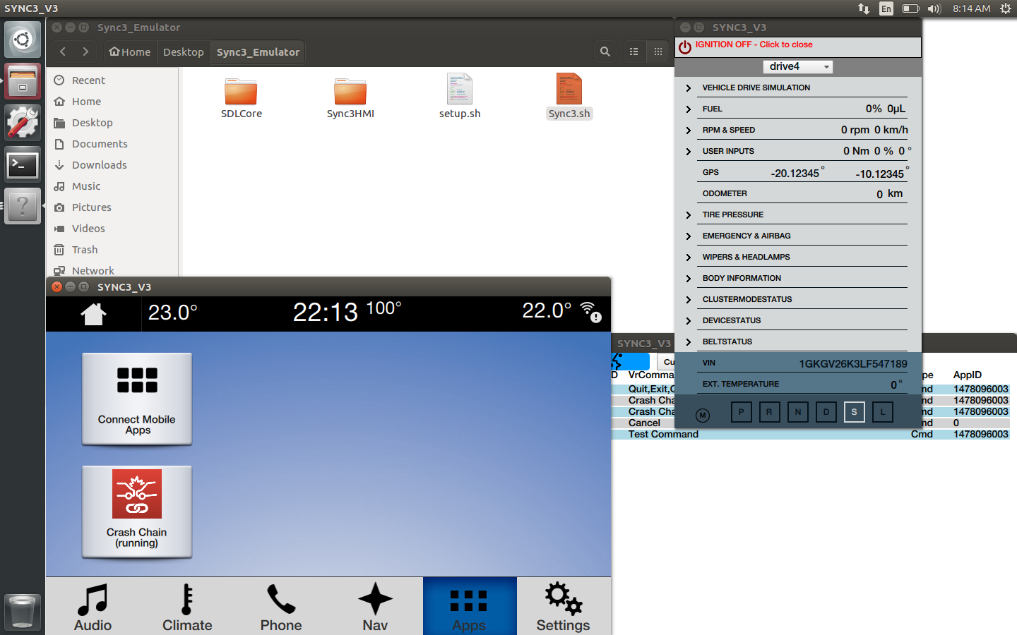

Figure 2: Ford Car Crash Simulator

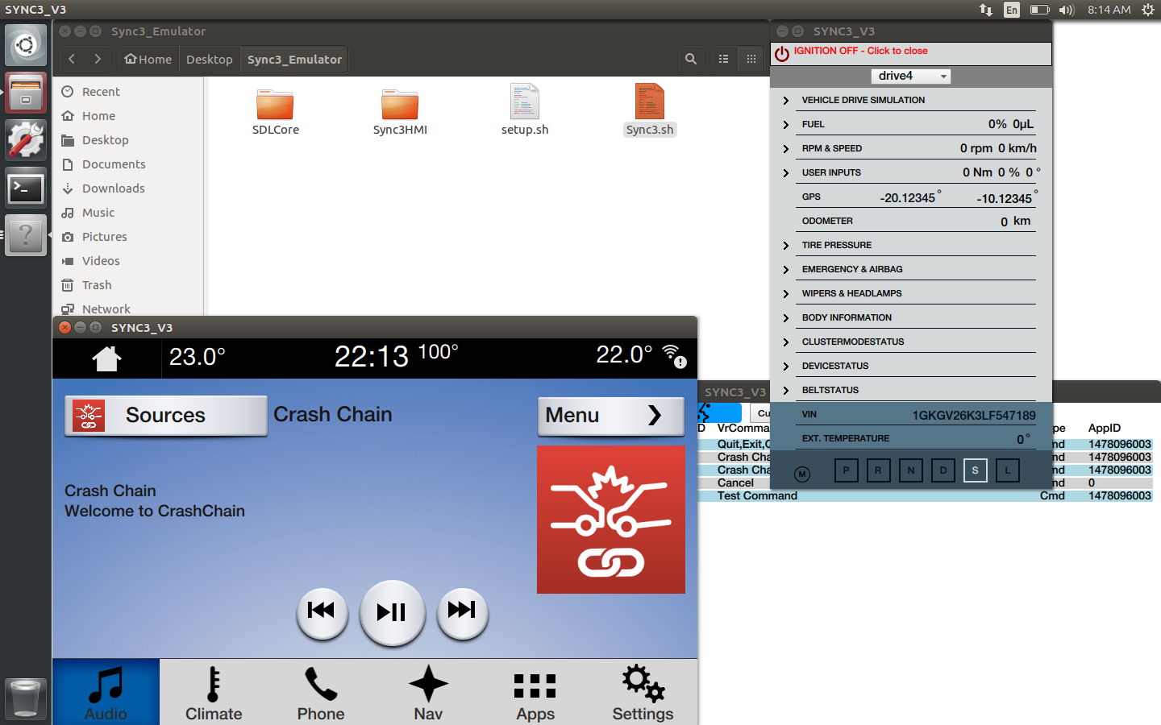

Figure 3: Data attributes available from the Ford API

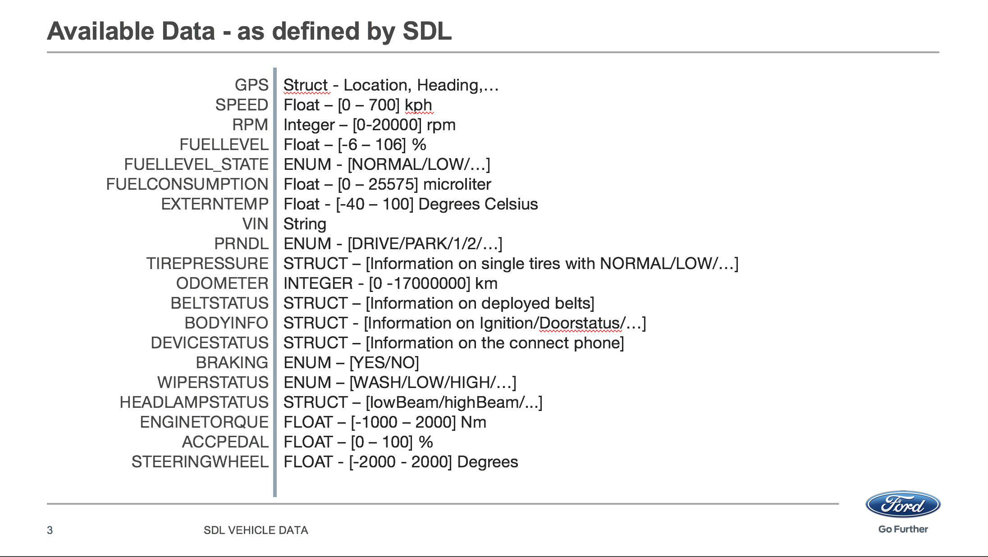

Figure 4: TRON Blockchain for storing vehicular collision data

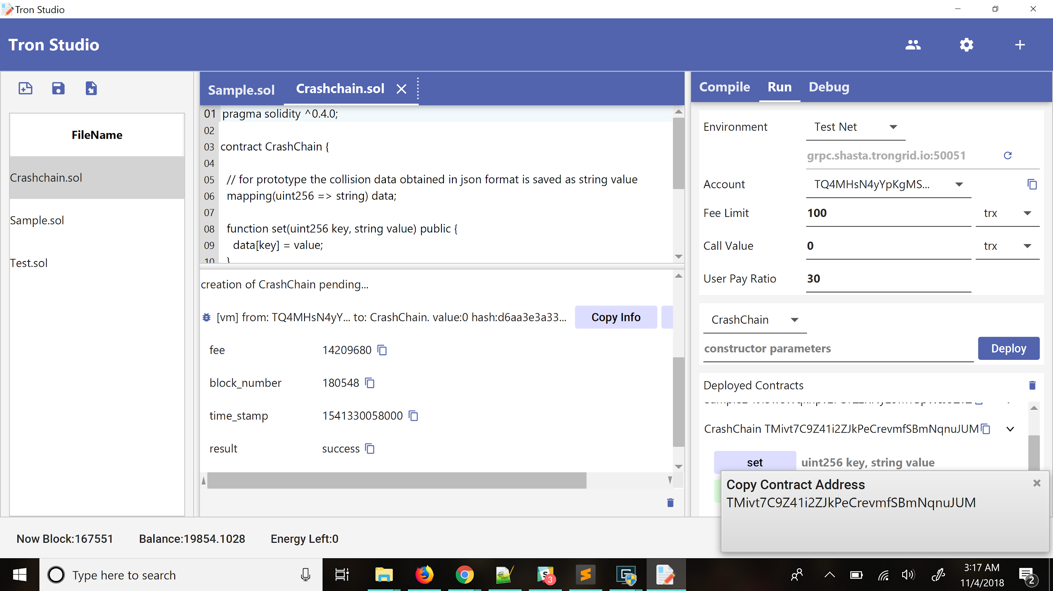

Figure 5: CrashChain Android App for Drivers

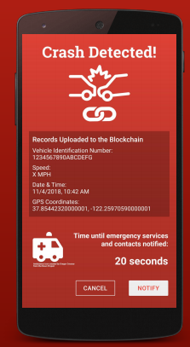

**Value Proposition**

Our initial hypothesis offered the below-mentioned key value propositions to different key stakeholders:

* Vehicle drivers:
  + Peace of mind via access to tamper-evident data around car accidents and
  + Time savings by avoiding long negotiation process regarding who is at fault in case of an accident
* Vehicle manufacturers:
  + Better brand image by offering transparent system regarding data collection and
  + Time savings by avoiding long negotiation process regarding who is at fault in case of an accident (i.e., software or hardware error)
* Law enforcement:
  + Time savings and cost savings by avoiding long negotiation process regarding who is at fault in case of an accident and
  + Access to better data
* Insurance companies:
  + Better data for more accurate claim adjustments,
  + Faster processing time with relevant data more easily accessible,
  + Labor cost savings from increases in workflow efficiency.

**Methods**

We took the above-mentioned prototype along with the description of our value propositions to multiple people. We became a part of Blockchain@Berkeley and the Mobility Open Blockchain Initiative (MOBI) to get a deeper understanding of the ecosystem in which we would be operating. We interacted with blockchain startups, tech companies like IBM and executives from major auto manufacturers like VW, BMW, etc. We also conducted research and interacted with lawyers in the field. Apart from these resources, we also carried out multiple interviews with professional drivers, people who have been in accidents, officers at the Department of Homeland Security, CyberSecurity consultants, venture capitalists, and car insurance companies regarding the major challenges they face, and especially those that they foresee as autonomous cars get closer to adoption.

We learned that there are already laws in place that car manufacturers need to follow with respect to reporting car data from the black box. In addition to this, there are a certain set of prescribed standards on what format this data should be in. While using the infrastructure provided by Ford, we simulated multiple conditions in which the car transitioned into the crash state. There were two methods to induce crashes, with varying severity, which we exploited. Through the APIs, we also tried to access multiple data points from the car and these were stored in Android logs using the adb logcat interface for further analysis.

We explored what kind of frameworks would be best for the development of such a product for deployment. While the initial prototype was built on the TRON blockchain due to the ease of access to resources/engineers, we also explored the features from other blockchain frameworks like Ethereum and Ripple. We also explored enterprise offerings like IBM Blockchain for our purposes, due to the added security and support features provided by the platform.

**Results**

Over the period of 5 months, we’ve conducted numerous interviews with various stakeholders, ranging from vehicle drivers, automobile consortium, law enforcement, consultants, venture capitalists, automobile exporters, and insurance companies. In addition to this, we have explored the features of multiple blockchain frameworks, different automotive environments, studied law and regulation policies around the subject and simulated crash scenarios in varied conditions. Our key findings from these avenues of research are summarized below:

* A low frequency of accidents relative to the driving history indicates that casual drivers may not be the most appropriate customer. Even professional drivers experience low frequency as well. The average individual is expected to be in a car accident once every 18 years or so.[2]
* The data provided from the black boxes in cars is fairly standard considering regulatory standards and laws that are implemented in order to ensure consistent interaction methods and smooth functioning of vehicles on the roads. This makes the solution agnostic to frameworks, however access to the data will be determined by the access control privileges for multiple variables, since car data is highly sensitive.
* By using multiple car crash scenarios, we have been able to learn the change in data points, but these are very specific to each crash and collision. Unless aggregated data is provided, it is difficult to discern points to assign liability.
* There is enough reason to tamper with data, especially in case of auto manufacturers failing to meet certain standards of regulation, where there has been a loss of life or property involved. 23 different softwares have been identified to tamper with OBD data. Hence a source of truth in itself would certainly be valuable.
* However, additional OBD data may not make a difference determining the liability for many car accidents (fender benders) where the fault is clear. In addition, the driver reported information was often enough for approving insurance claims. Professional drivers, in general, were satisfied with the service of their current insurance agents and didn’t demonstrate a burning need for our solution.
* A major challenge with utilization of OBD car crash data is the value of individual data points that are provided by the system. Over time, the aggregated data can be analyzed to certify driver behavior. But crashes are isolated incidents and it is very hard for insurance companies to discern fault using the values that are provided, without context. Hence, human descriptions or camera feeds will be needed. The data alone cannot act as a way to assign liability.
* Blockchain would be the best platform for development of a source of truth due to its tamper proof nature. Since the data is occasional but highly time-sensitive, it would be in the best interest to have a framework with high throughput.
* Among all the explored frameworks, Enterprise blockchains with permissioned access to privileged information would be the best way forward to implement such a solution. Different kinds of privileges would be key in order to ensure the privacy of individuals and fair usage of the data.
* In terms of time savings, it’s hard to break into insurance companies process to quantify this value as each insurance company’s process is proprietary information. In addition, we learned that enterprise rental agencies can file an insurance claim in about 10 minutes.

**Future Work and Vision:**

The system summarized in this report could solve the critical problem of timely response in case of emergencies and potentially save millions of lives on roads. The data attributes that we used in this prototype are just the tip of the iceberg. Additionally, we could collect a driver’s biometric data and speech transcripts, and store the front/rear camera videos to model a crash scene. This hybrid or contextual data could then be analyzed and turned into a gold mine of information to help develop models to predict and prevent car crashes or design systems to augment driving skills. Although the technology used currently might be considered to be in a nascent stage, we believe that research at the intersection of automobiles and blockchain should continue to focus on finding ways to address the problem of determining liability in car accidents and establishing a standard automated framework for emergency response as the advent of autonomous cars would only aggravate this problem.

1. "Road Safety Facts — Association for Safe International Road Travel." <https://www.asirt.org/safe-travel/road-safety-facts/>. Accessed 3 Dec. 2018.
2. "How Many Times Will You Crash Your Car? - Forbes." 27 Jul. 2011, <https://www.forbes.com/sites/moneybuilder/2011/07/27/how-many-times-will-you-crash-your-car/>. Accessed 6 May. 2019.